

Build a Use Case -Tokenized Supply Chain Prototype



**Objective**

Create a simple prototype that tokenizes physical product batches as unique tokens (NFTs) to enable immutable tracking, ownership transfer, and status updates across supply-chain participants (Farmer → Distributor → Retailer → Consumer). Demonstrate minting, metadata storage (IPFS), transfers, and an on-chain status history.

**Apparatus/Software Used:**

* Solidity (Smart contract language)
* Hardhat (development & testing) or Remix for quick tests
* OpenZeppelin contracts (ERC-721)
* Ganache / Hardhat node (local blockchain)
* MetaMask (wallet testing)

**Theory/Concept:**

Tokenization maps a real-world product or batch to a unique on-chain token (NFT). Token metadata holds product details and an IPFS URI for richer data (certificates, photos). Smart contracts record transfers and status updates; combined with QR codes, consumers can verify history and provenance.

Benefits: immutable audit trail, secure ownership transfer, automated checks with smart contracts, tamper-evident product history.



**Procedure :**

**Prepare environment**

* Install Node.js, Hardhat, OpenZeppelin.
* Start local blockchain: npx hardhat node or Ganache.

**Create contract**

* Copy the above TokenizedSupplyChain.sol into contracts/.

**Compile & Deploy**

* Use Hardhat or Remix to compile.
* Deploy to local node. Save contract address & ABI.

**Prepare product metadata**

* Create JSON metadata:

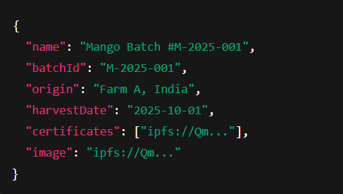

* Upload JSON to IPFS/Pinata → get ipfs://Qm... URI.

**Mint token**

* Owner (manufacturer) calls mintProduct(to, batchId, ipfsURI, Stage.Manufactured, "Harvested & Packed").
* Note returned tokenId.

**Simulate supply chain actions**

* Distributor receives token (owner transfers token or transferFrom).
* Call updateStatus(tokenId, Stage.InTransit, "Shipped via Truck").
* Retailer receives and sets updateStatus(tokenId, Stage.ForSale, "Arrived at Warehouse").
* Optionally, consumer purchase triggers transferFrom to buyer.

**Verify**

* Call getHistoryCount and getHistoryEntry to view events.
* Scan QR code (links to token metadata page) → show IPFS metadata + chain history.

**Observation table:**

